# Exercise-1

Create a new web page and create a Form with following form controls.

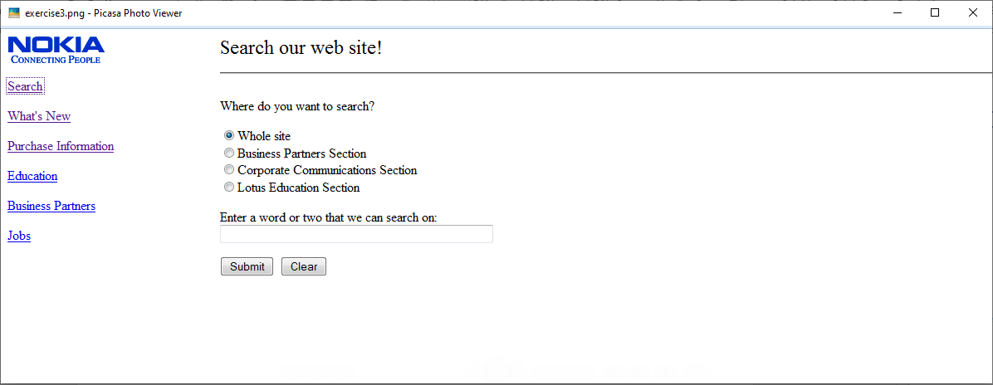

# Exercise 2

Create a new web page and create a Form with following form controls. [ Hint: Make use of TABLE].

